**FABIEN CHANGES AND BUG LIST**

1. **Move the field of the portfolio form like this : → done**

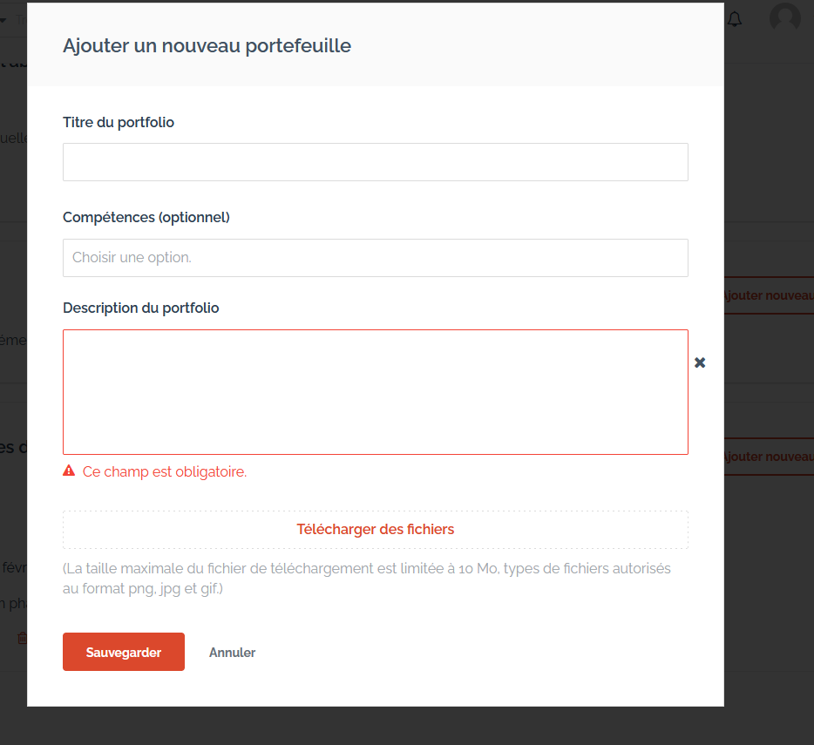

1. **Show the discontinue button to the freelancer on the workspace ( big bug ) → set up escrow**

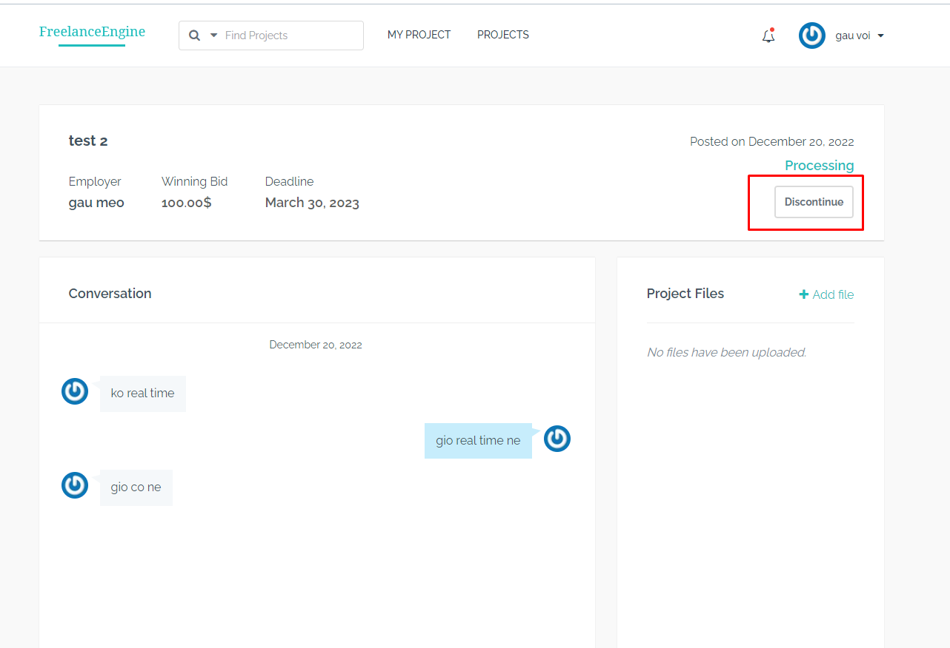

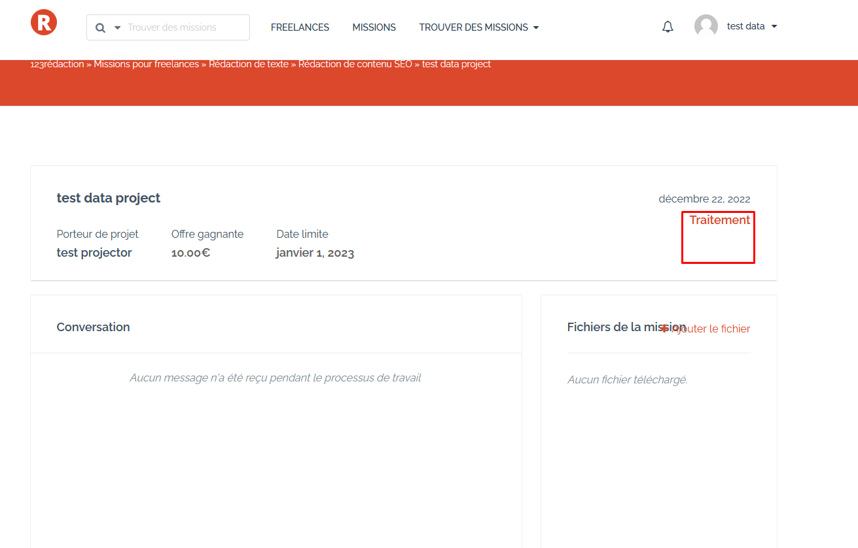

1. **Fix the text overlay bug in workspace : → done**

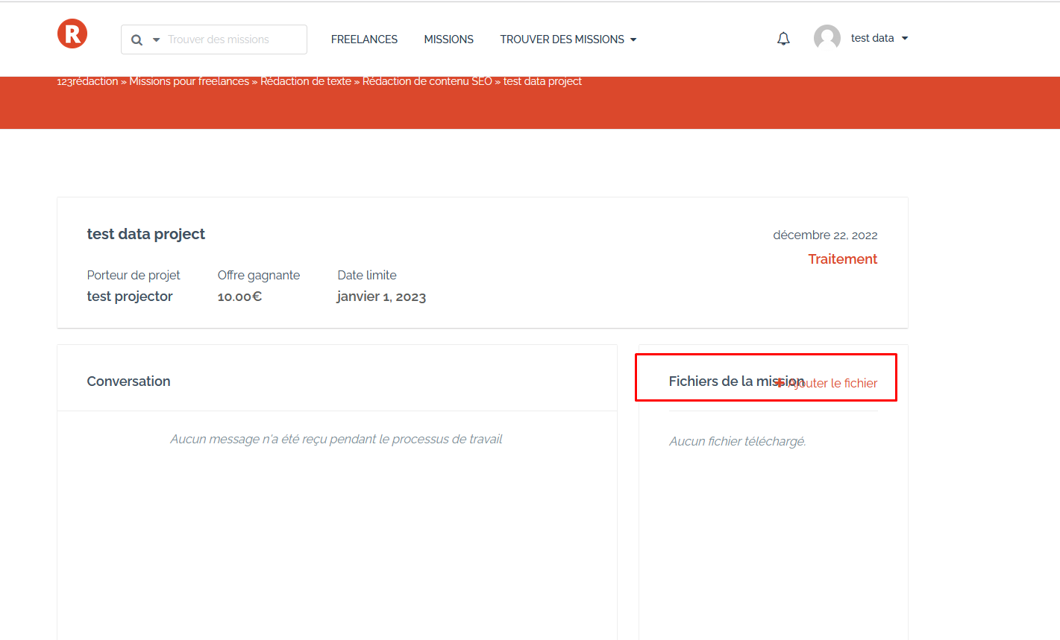

1. **Fix bug : too slow to get new messages in the workspace ( big bug ) : → done**

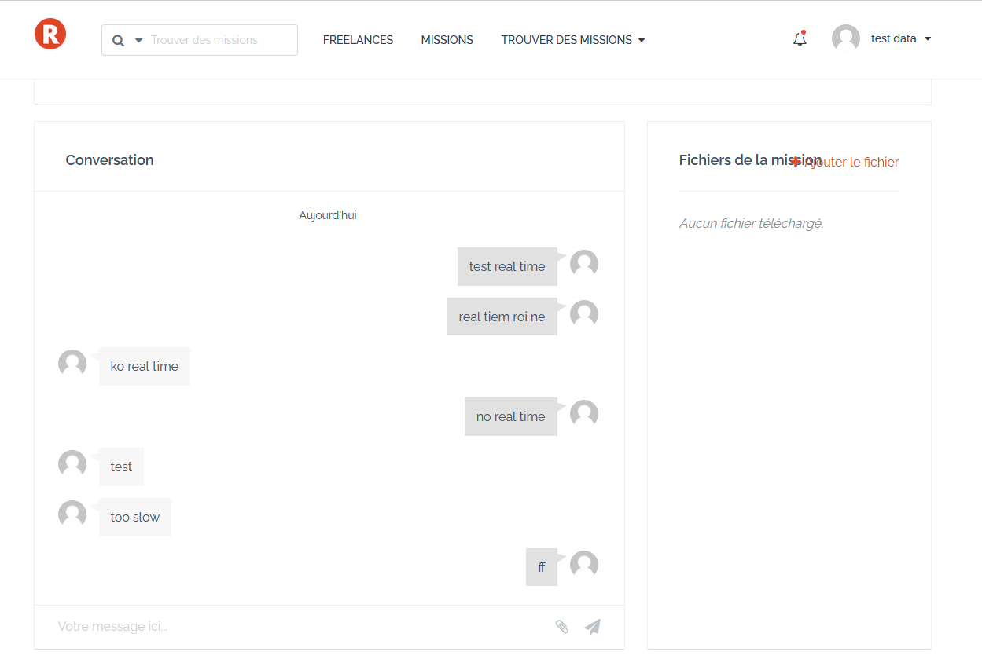

1. **Fix the bugs about the layout of the profile page : → not happen**

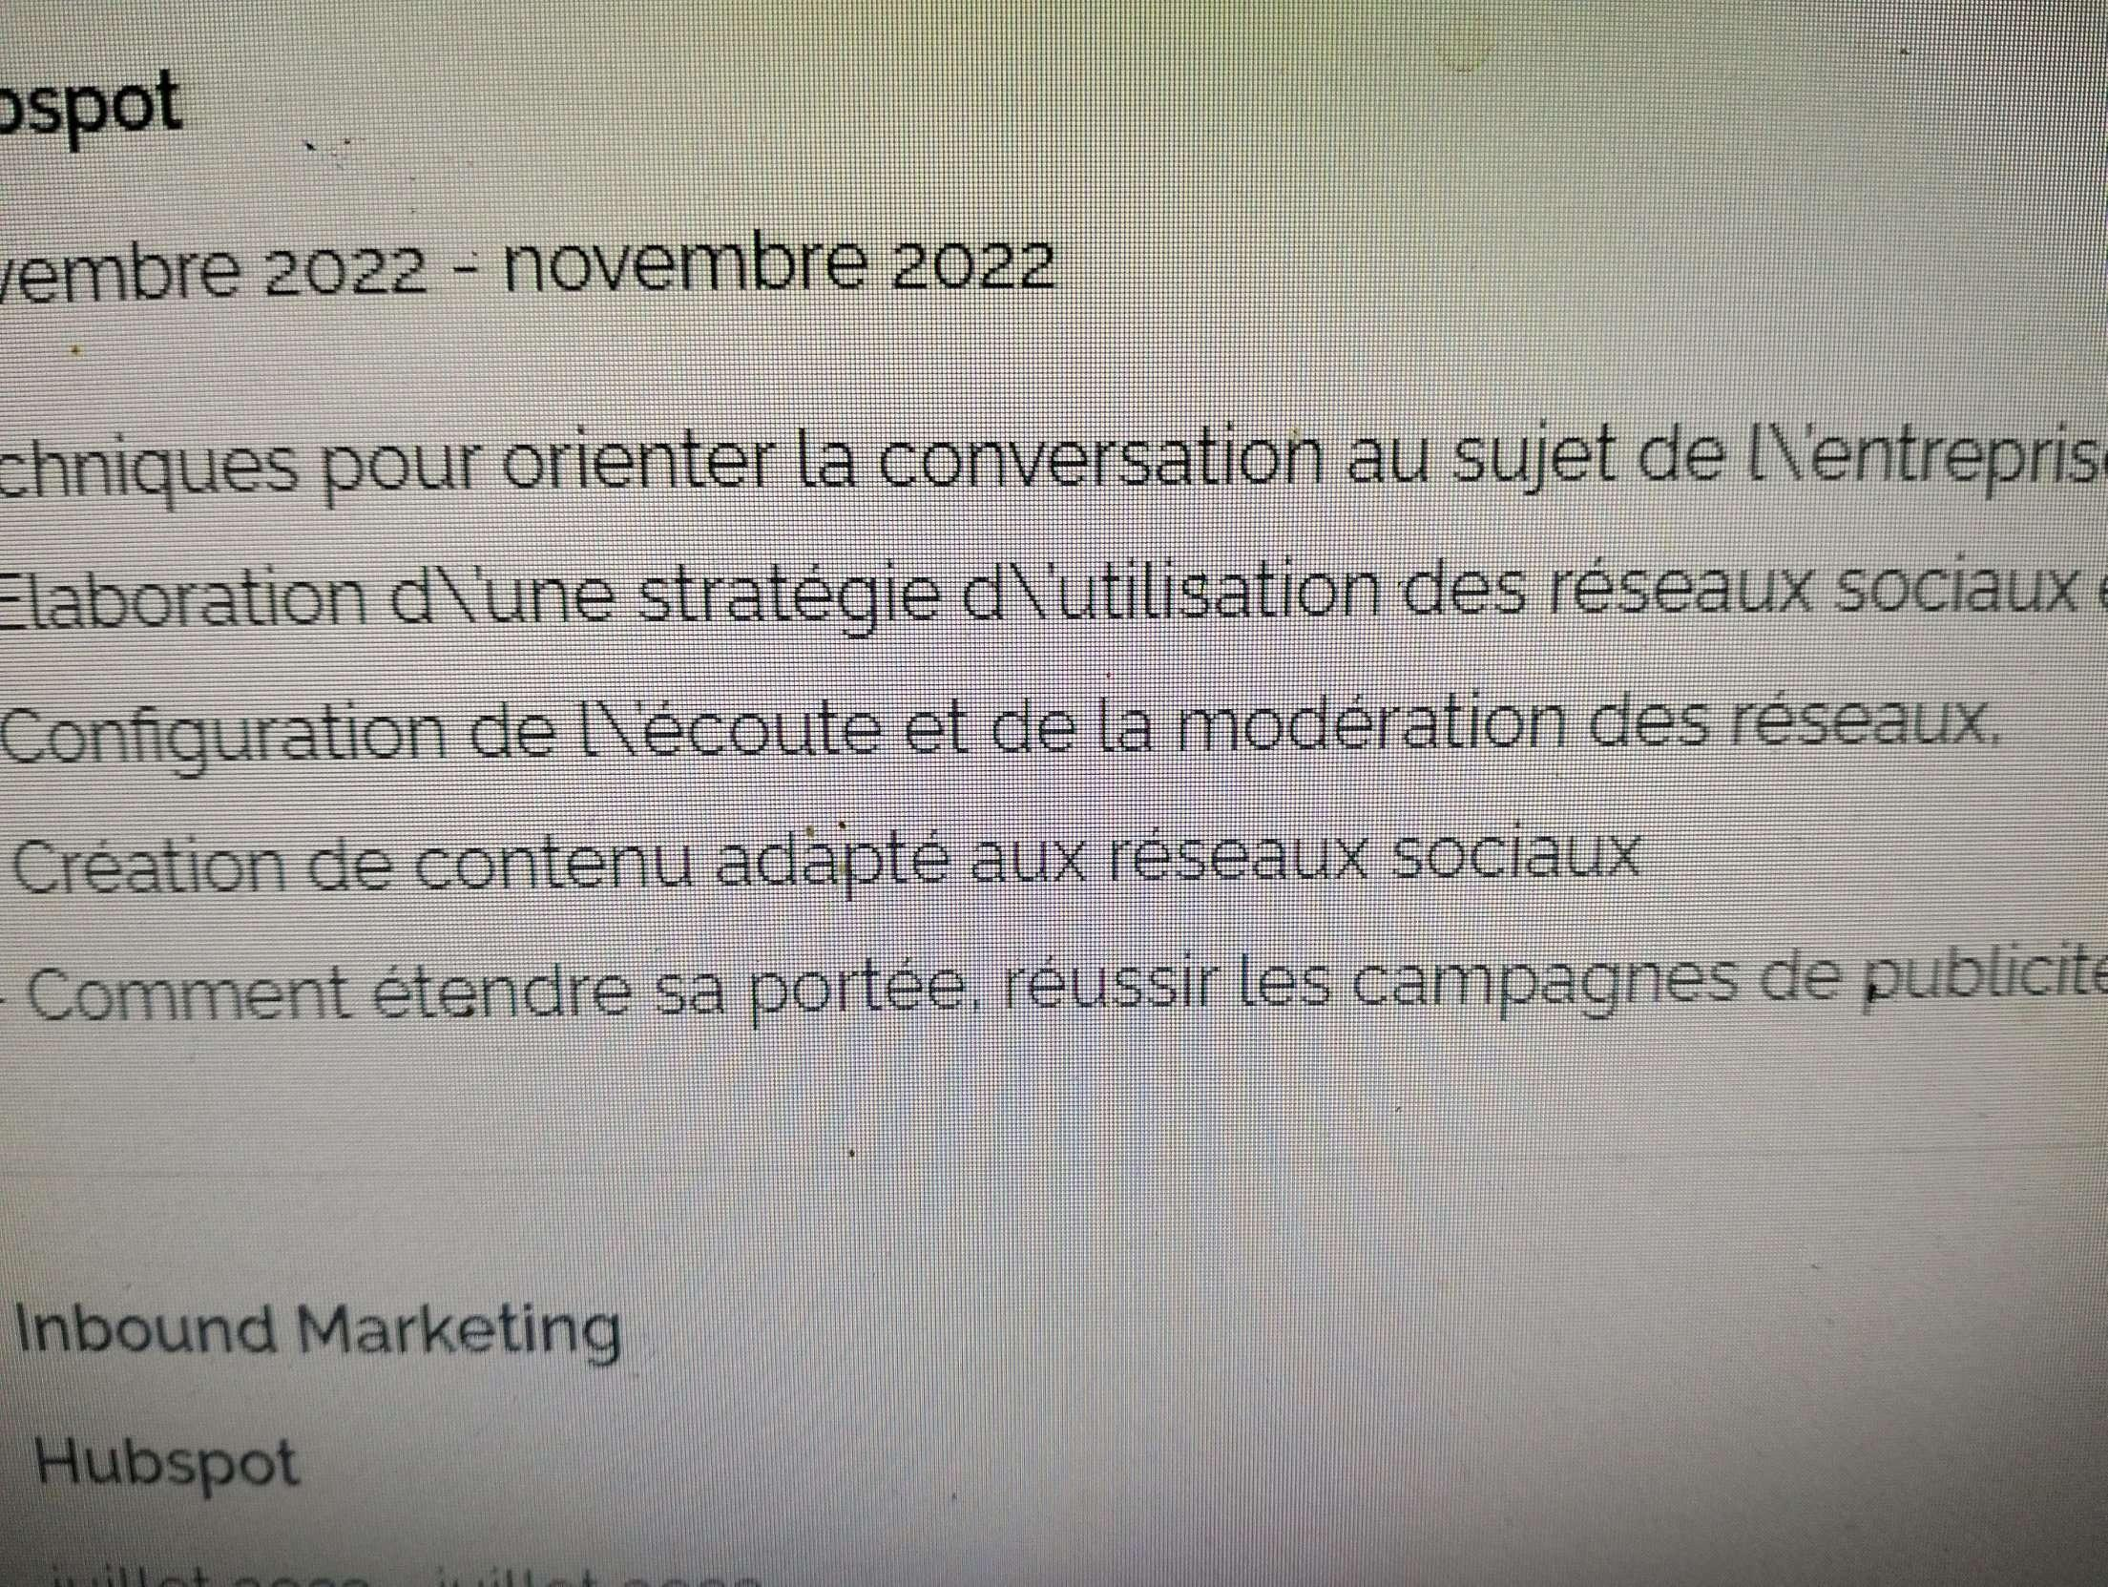

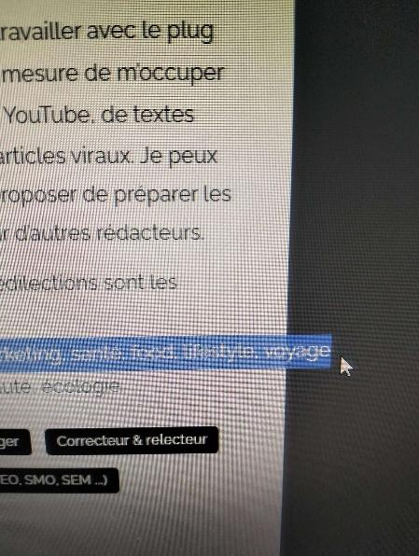

1. **Only show HTML, some icons and limit 200 characters for the description in the profile list. → not happen**

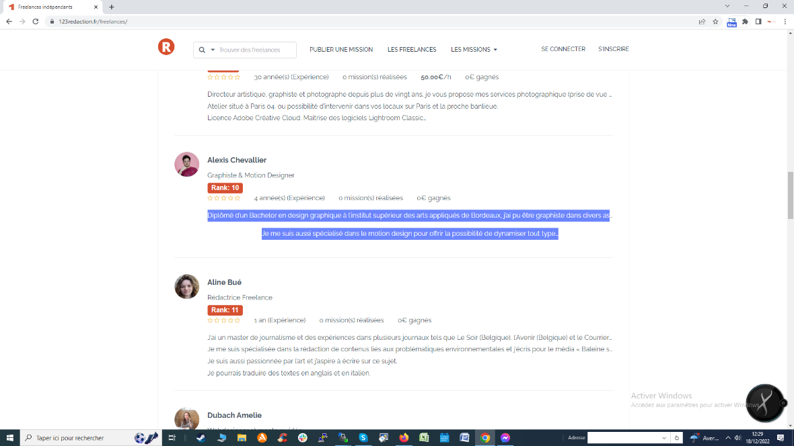

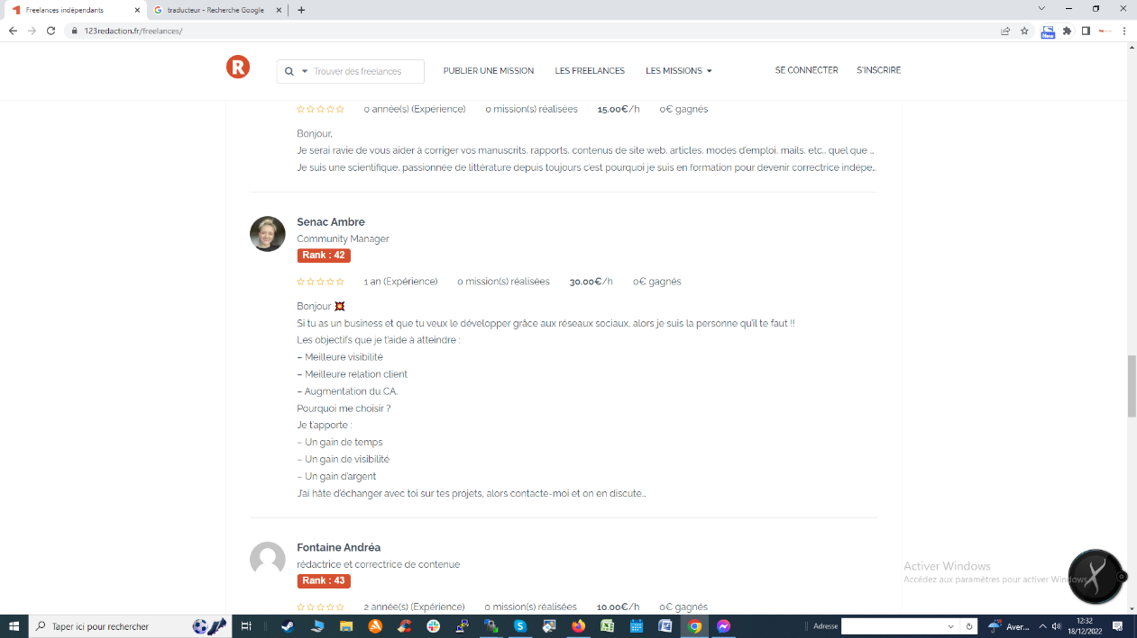

1. **Add the edit button to the single project page. 🡪 this is a feature because by default, FreelanceEngine does not allow the employer to be able to edit after the project is published → done**

